**CSE370 : Database Systems**

**Practice Sheet**

**Indexing and Hashing**

*Solutions are at the end of the document. SOLVE IT YOURSELF first.

Question 1:

An EMPLOYEE file with ID# as the key field includes records with the following ID# values: 8, 5, 1, 7, 3, 12, 9, 6. Suppose that the search field values are inserted in the given order in a B+-tree of order n = 3; show how the tree will expand and what the final tree will look like.

Question 2:

An EMPLOYEE file with ID# as the key field includes records with the following ID# values: 8, 5, 1, 7, 3, 12, 9, 6. Suppose that the search field values are inserted in the given order in a B+-tree of order n = 4; show how the tree will expand and what the final tree will look like.

Question 3:

1. An EMPLOYEE file with ID# as the key field includes records with the following ID# values: 15, 5, 20, 10, 65, 55, 60, 50, 30, 25, 35, 90, 85, 95, 105, 100, 110, 115. Suppose that the search field values are inserted in the given order in a B+-tree of order n = 4; show how the tree will expand and what the final tree will look like.
2. After building the tree in this sequence, describe in your words how you will search for these values in the tree: 65 and 120.

Question 4:

1. Discuss the similarities and differences between indexing and hashing.
2. Compare and contrast primary and secondary indexing with examples
3. What is multilevel indexing? Discuss the necessity of multilevel indexing.
4. Compare and contrast sparse indexing and dense indexing.

Question 5:

Suppose you have a table titled ‘“Instructor”.

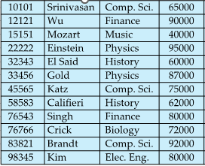

1. Make a hash index on attribute instructor_id. Suppose the number of buckets in the hash index is 5 and each bucket can house 2 index entries at max. Bucket overflow is handled using forward chaining.

The hash function, h = (sum of all digits in id) % 5

1. Explain how to search for the following search keys in your hash index.

* 45565
* 11113

Question 6:

Suppose you have a table titled ‘“Instructor”.



Make a hash index on attribute instructor_name (2nd column). Suppose the number of buckets in the hash index is 5 and each bucket can house 3 index entries at max. Bucket overflow is handled using forward chaining. The values of each character from A-Z (or a-z) is 1-26 respectively

The hash function, h = (sum of the values of each character in name) % 5

Ex:  
h(Wu) = (23 + 21) % 5 = 4

Question 7:

Suppose you have the table below for “Instructors” for a School Database with columns ID,

Name, Subject and Salary respectively:

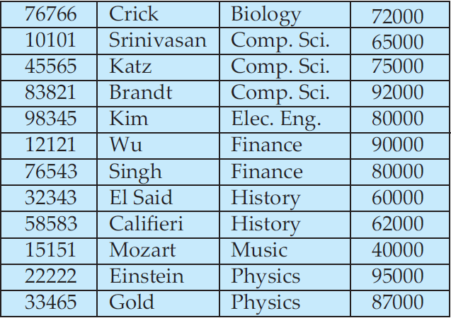

Suppose the number of buckets in the hash index is 5 and each bucket can hold 3 index entries at max. Construct a hash index on attribute ID. Bucket overflow is handled using forward chaining. The hash function, h = (First digit of ID) % 5.

Now let's assume there is another hash function, h = (Last digit of ID) % 5.

Now compare which hash function is more uniform.

**SOLUTIONS:**

Answer 1:

|  |
| --- |

Answer 2:

|  |
| --- |

Answer 3:

|  |
| --- |

1. Searching 65:

Start at root with values 55, 100. 65 is RHS of 55 which has values 65 and 90, so go to RHS of 65 and we reach the leaf, the first value is 65.

Searching 120:

Start at root with values 55, 100. 120 is RHS of 100, where the node value is 110. 120 is again in the RHS of node 110, we reach the leaf node. The values are 110 and 115, so 120 does not exist.

Answer 4:

Take help from slides, books and online materials to write a concise answer to each question in your own words.

Answer5:

A.

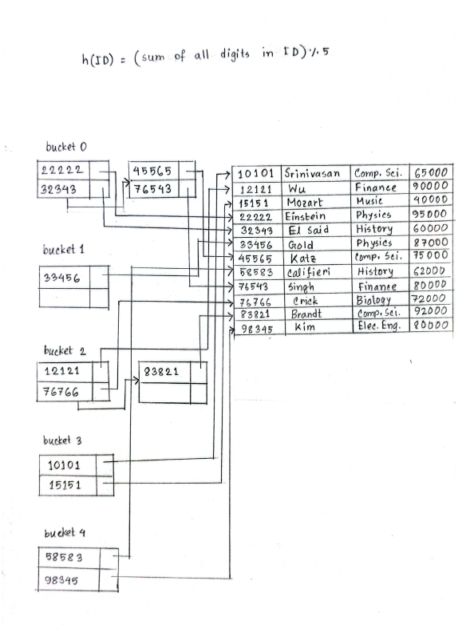

B:

**Searching for 45565:**

h(45565) = 0

Therefore, we examine the buckets located at index 0. Upon retrieving this initial bucket, we encounter two entries, namely 22222 and 32343. As our intended record has not been found, we proceed to retrieve the second bucket, from which we obtain the entry 45565.

**Searching for 11113:**

h(11113) = 2

Therefore, we examine the buckets located at index 2. Upon retrieving the initial bucket, two records, namely 12121 and 76766, are obtained. Subsequently, retrieving the second bucket yields the entry 83821. At this point, all buckets at index 2 have been retrieved, and the end of the linked list has been reached. Consequently, the search for the key 11113 concludes without success.

Answer 7:

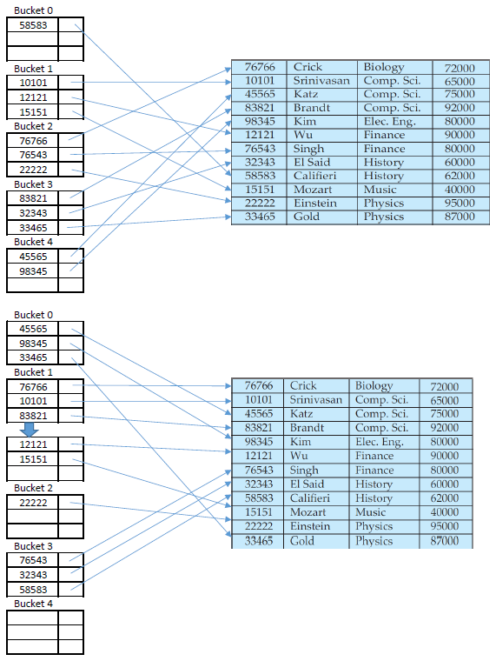

The 1st hash function is more uniform compared to the later one. As no buckets were empty in the 1st case. However, in the 2nd case not only were there empty buckets but also there was an overflow in the bucket.